Lab 3
Name: Ahsan Baig
Section: 5C
23L-0515

Extra activity:
IP Address: 142.250.80.110
Name Server of google.com: ns1.google.com, ns2.google.com, ns3.google.com, ns4.google.com
Domain Name Server of google.com: 8.8.8.8
Country and City: San Francisco CA, United States

HTTP Analysis:
- The Basic HTTP GET/Response Interaction
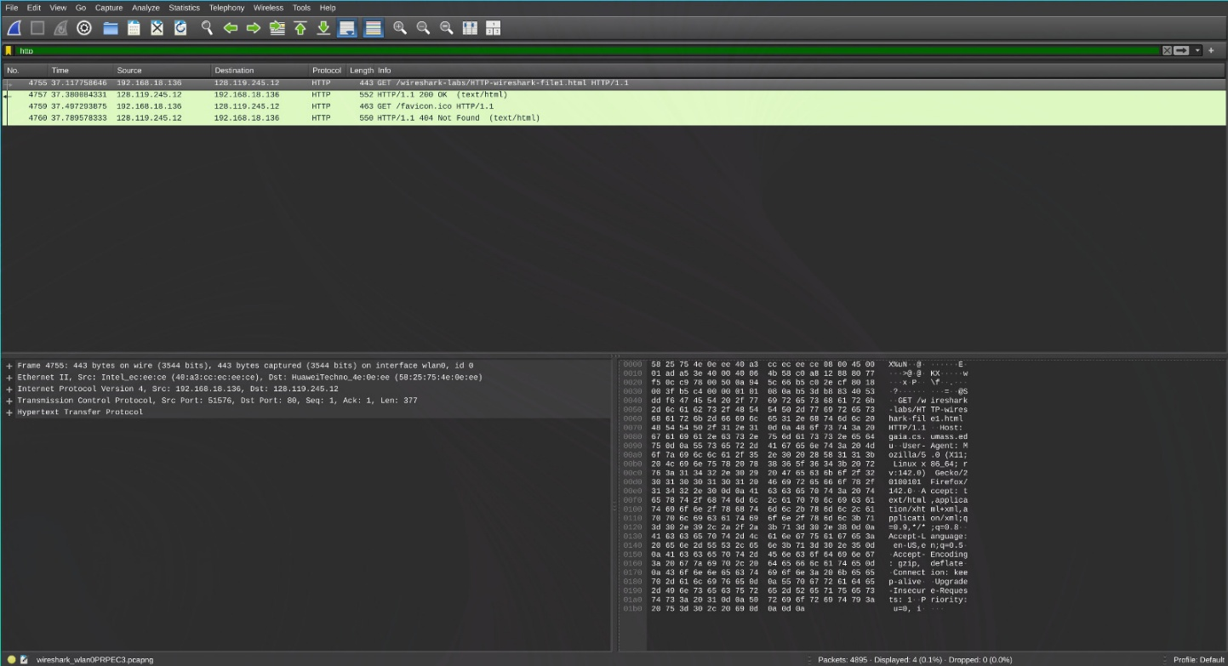

Q. Is your browser running HTTP version 1.0 or 1.1? What version of HTTP is the server
running?
A. Version 1.1
Q. What languages (if any) does your browser indicate that it can accept to the server?
A. en-US, en q=0.5
Q. What is the IP address of your computer and the ‘gaia.cs.umass.edu‘ server?
A. Server: 192.168.18.136. IP address: 128.119.245.12
Q. What is the status code returned from the server to your browser?
A. 200
Q. When was the HTML file that you are retrieving last modified at the server?
A. Mon, 08 Sep 2025 05:59:01 GMT
Q. How many bytes of content are being returned to your browser?
A. 552 bytes

- The HTTP Conditional GET/Response Interaction
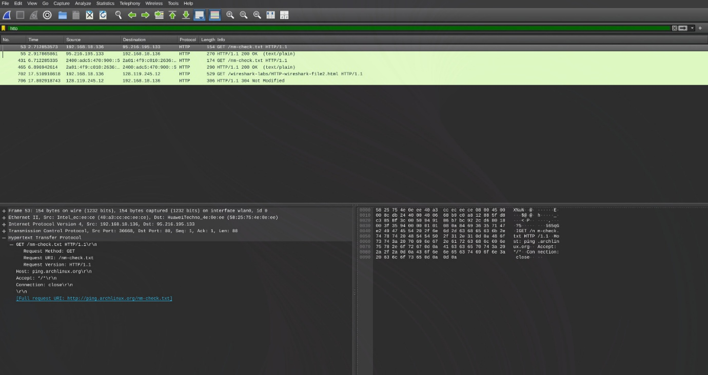
Q. Inspect the first HTTP GET request. Do you see an “IF-MODIFIED-SINCE” line?
A. Yes
Q. Inspect the server response. Did the server explicitly return the contents of the file? How can you tell?
A. No, it did not. I received code 304 instead of the usual 200
Q. Inspect the second HTTP GET request. Do you see an “IF-MODIFIED-SINCE” line? What information follows it?
A. Yes, I see it, Mon, 08 Sep 2025 05:59:01 GMT
Q. What is the HTTP status code in response to the second GET? Did the server return the
file’s contents? Explain.
A. 306, yes it did return content, 306 bytes are showing in Frame.

5. HTTP Authentication
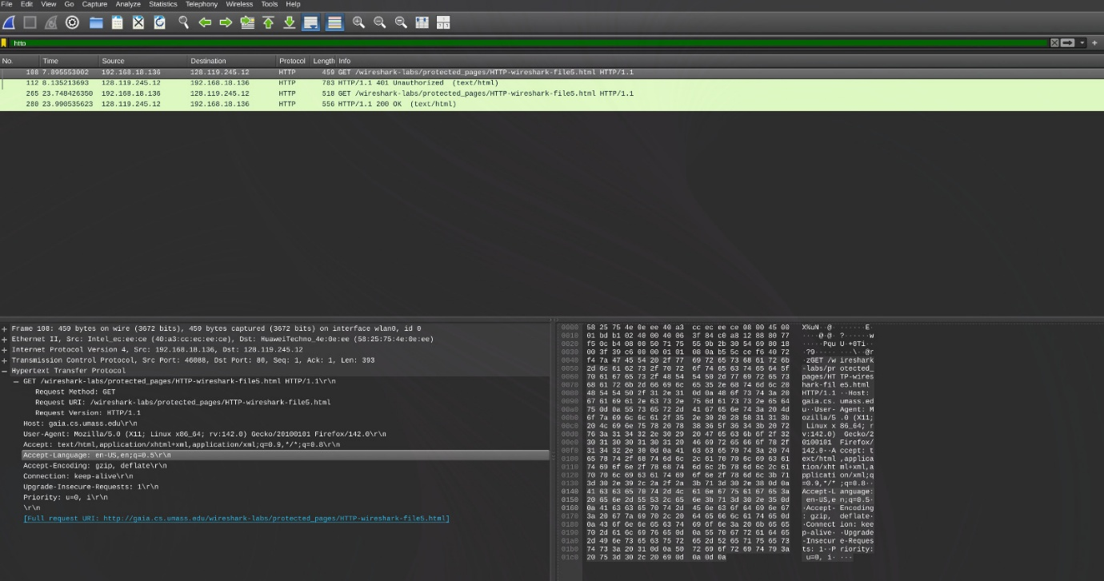
Q. What is the server’s response (status code and phrase) to the initial HTTP GET message?
A. 401 Unauthorised
Q. When your browser sends the HTTP GET message for the second time, what new field is included?
A. Authorization

DNS Analysis
- Nslookup
Q. Run ‘nslookup’ to obtain the IP address of a web server in Asia. What is its IP address?
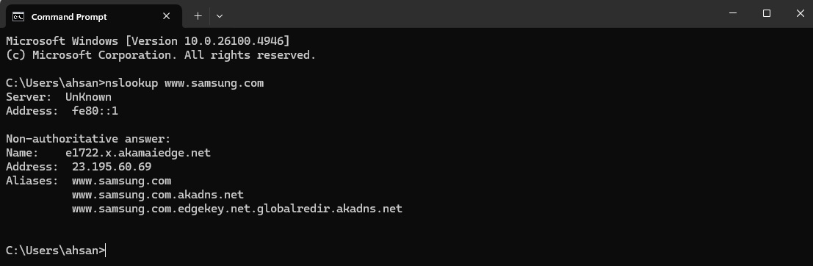
A. 23.195.60.69
Q. Run ‘nslookup’ to determine the authoritative DNS servers for a university in Europe.
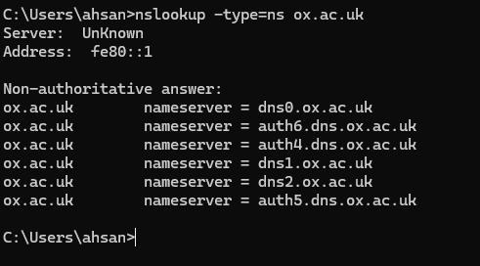
A. Non authoritative answer:
ox.ac.uk nameserver = dns0.ox.ac.uk
ox.ac.uk nameserver = auth6.dns.ox.ac.uk
ox.ac.uk nameserver = auth4.dns.ox.ac.uk
ox.ac.uk nameserver = dns1.ox.ac.uk
ox.ac.uk nameserver = dns2.ox.ac.uk
ox.ac.uk nameserver = auth5.dns.ox.ac.uk

Q. Run ‘nslookup’ so that one of the DNS servers from the previous question is queried for the mail servers for Yahoo! mail.
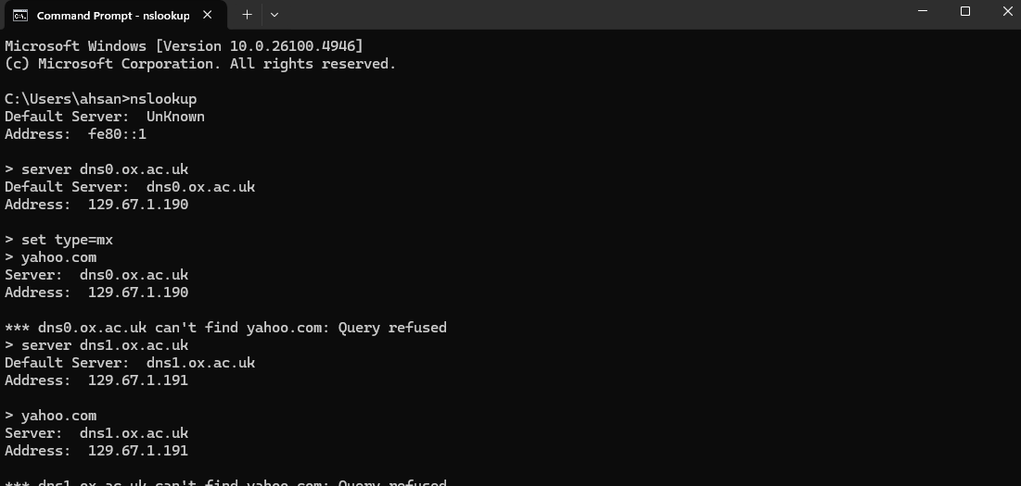

2. ipconfig
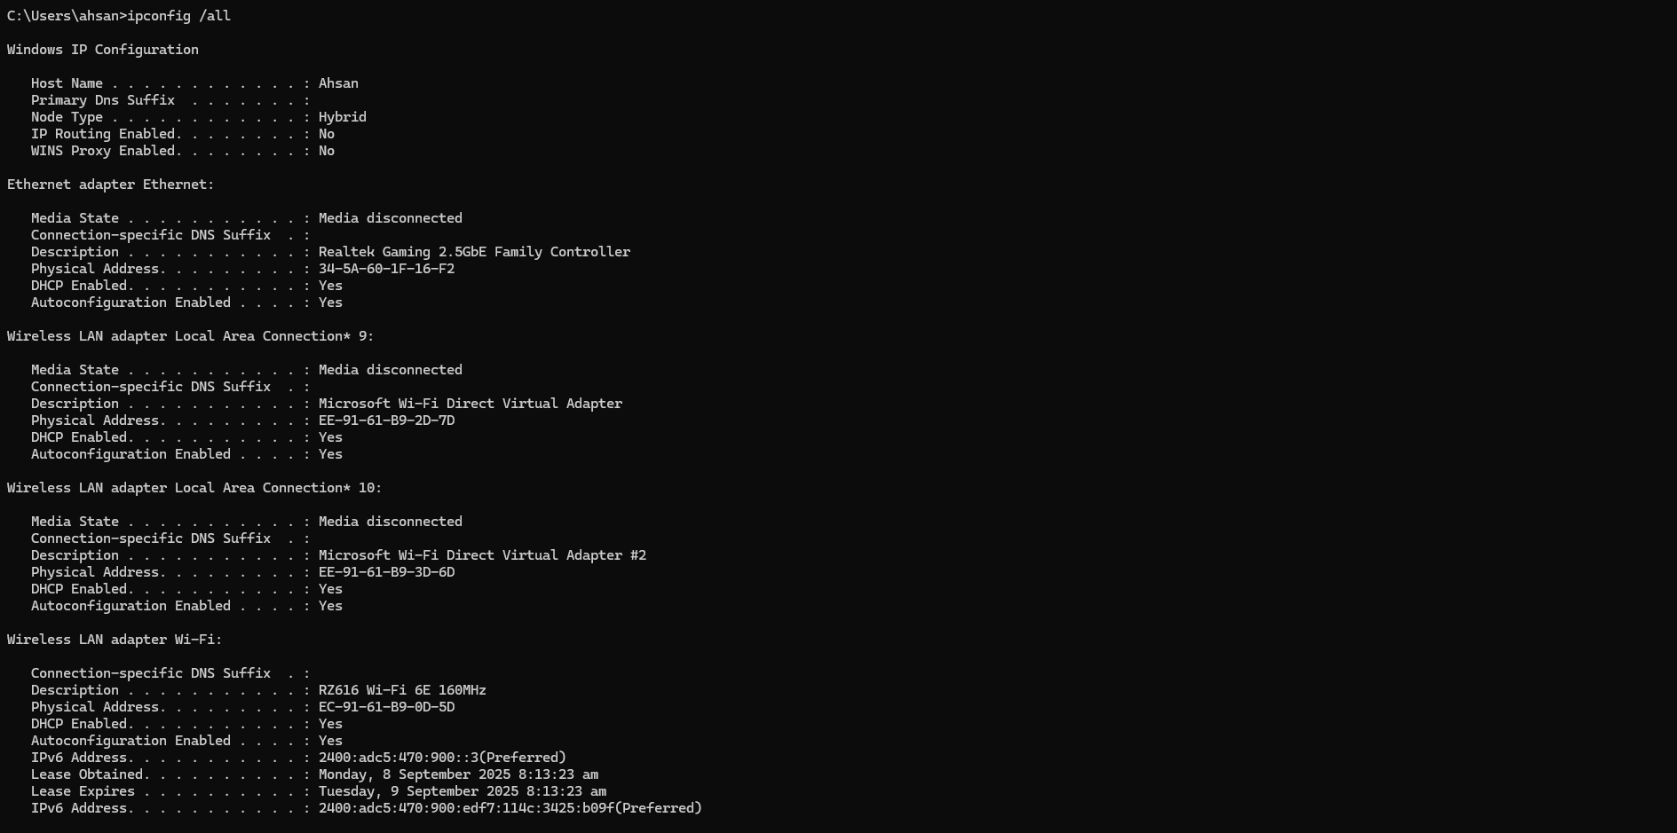
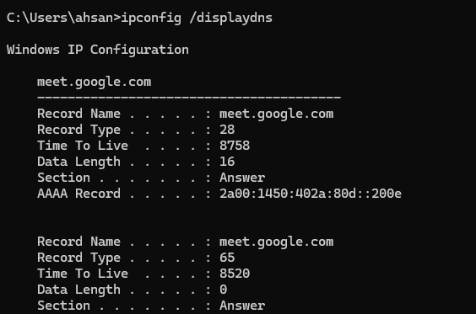
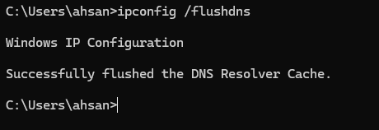
3. Tracing DNS with Wireshark
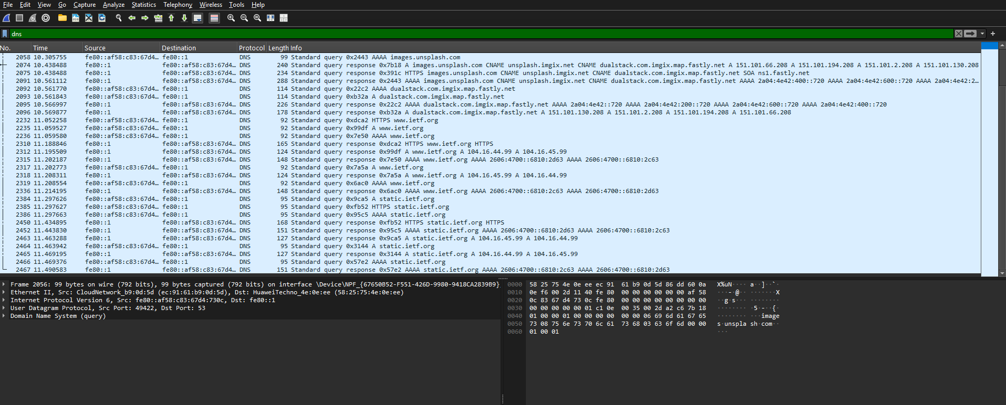
Q. Locate the DNS query and response messages. Are they sent over UDP or TCP?
A. UDP
Q. What is the destination port for the DNS query message? What is the source port of the
DNS response message?
A. Destination: 53. Source: 63313
Q. To what IP address is the DNS query message sent? Is this the same as your local DNS
server’s IP address (found using ‘ipconfig’)?
A. IP address: 192.168.1.1. Same as my local DNS server’s IP address.
Q. Examine the DNS query message. What “Type” of DNS query is it? Does it contain any “answers”?
A. Standard Query (Type A), no answers.
Q. Examine the DNS response message. How many “answers” are provided? What does each answer contain?
A. 1 Answer.
The answer contains:
- The queried domain name: www.ietf.org
- The record type: A (Host Address)
- The resolved IPv4 address: 4.31.198.44
- The Time-to-Live (TTL) value indicating how long the record can be cached.

